Computer Language Coding Concepts

Object Reference Interface Assignment in a Diagram
The principle of object reference interface assignment is explained in the article Object Reference Interface Assignment. This article demonstrates the expression of it in a diagram.

An assignment is a call to an assignment command, but the expression of an assignment call is given a more basic notation than a command call. An object reference object assignment looks as follows in a diagram:

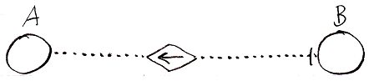

The fact, that it is a dotted line, expresses, that it is an interface assignment. The fact that the diamond contains an arrow pointing to the reference target, makes it an object reference assignment. Altogether it is an object reference interface assignment. The access mark indicates the direction of the assignment. Object reference A is assigned as the interface target of object reference B.

About the notation of object reference assignment in general and diagrams of the effect of an object reference assignment, see the article Object Reference Assignment in a Diagram.

Command reference interface assignment works exactly the same. Here’s an example of a command reference interface assignment:

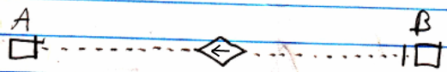

See also: Object Reference Interface Assignment, Object Reference Assignment in a Diagram, Assignment in a Diagram

Author & Copyright: Jan-Joost van Zon Date: July 25, 2008 – July 25, 2008 Location: Oosterhout, The Netherlands Status: Finished

